NAME:Rishik JK
REG.NO :192511052

CSA1702-ARTIFICIAL INTELLIGENCE
LAB EXPERIMENT

- Write the python program to implement Minimax algorithm for gaming

Aim
To write a Python program to implement the Minimax Algorithm for a two-player game.

Algorithm
- Start the program.
- Define the game tree with possible scores
- Set two players as Maximizer and Minimizer.
- The Maximizer tries to select the highest score
- The Minimizer tries to select the lowest score.
- Recursively evaluate the game tree using Minimax.
- Return the best possible score for the Maximizer.
- Display the optimal score.
- Stop the program.
OUTPUT:
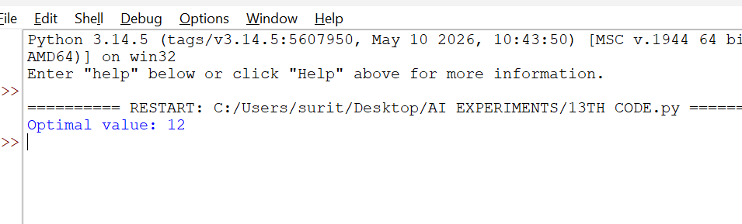

RESULT:
Thus, the Python program to implement the Minimax Algorithm for gaming was successfully executed, and the optimal value was determined.

